National University of Computer and Emerging Sciences



Lab Manual 6
SE3003 – Web Engineering

Course Instructor | Sir Mudassir Saeed
Lab Instructor(s) | Marwa Khan
Section | BSE 6A
Semester | Spring 2024

Department of Computer Science
FAST-NU, Lahore, Pakistan

HTML/CSS/JavaScript/jQuery

Important Note:
− You may find the syntax to accomplish these exercises from the lecture demo.
− Names of your submission files should start with your roll number throughout this semester.
− Make sure that the interface of your program is user friendly i.e. properly display information.
− Properly follow the coding standards

Task 01:
Write a code in which changes an HTML image by changing the src (source) attribute of an <img> tag. Use onclick event for this to turn on the light.
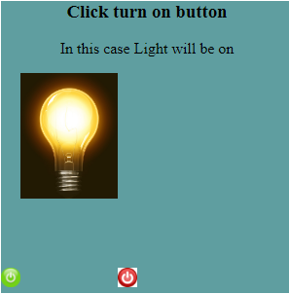
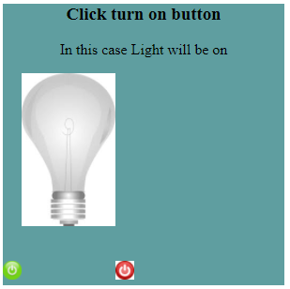

Task 02:
Write a code to change the font size after user clicks on a button as illustrated below:
Before:
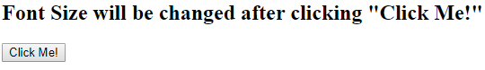
After:
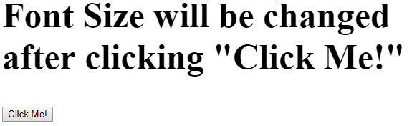
Task 04:
Write a javascript code which can take the input from user,
- After entering an input, the table of an input should be printed.

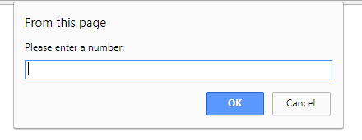
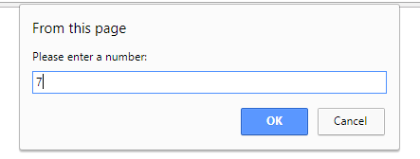

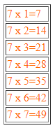

Task 04:
All these questions should be solved by using jQuery.
- Create a function that toggles the visibility of an element when a button is clicked.
- Write a script that displays a message when a user clicks on a specific button.
- Create a script that will change the background color of a div when a button is clicked.
- Write a script that will display an alert message when the user tries to submit a form without filling out all required fields.
- Create a script that will fade in an image when the user scrolls to a certain point on the page.
- Write a function that will add a class to an element when the user hovers over it. 7. Write a script that will display a modal window when the user clicks on a button.
- Create a function that will sort a list of items alphabetically when a button is clicked.
- Write a script that will display a tooltip when the user hovers over an element.

